**G pavan Kumar**

**916217**

**Stage-3 Day-69 Angular Hands-on**

**Hello World in angular**

SME to provide explanation about the following files in the generated code:

1. app.component.ts

2. app.component.html

3. app.module.ts

Modify app.component.html to display the message “Hello World” alone in the view.

**app.component.ts**

import { Component } from '@angular/core';

@Component({

  // selector: 'app-root',

  // templateUrl: './app.component.html',

  // styleUrls: ['./app.component.css']

  selector: 'app-root',

  template: `

    <h2>Hello World</h2>

    `,

})

export class AppComponent {

}

**app.component.html**

<hello-world></hello-world>

**app.modules.ts**

import { NgModule } from '@angular/core';

import { BrowserModule } from '@angular/platform-browser';

import { AppRoutingModule } from './app-routing.module';

import { AppComponent } from './app.component';

@NgModule({

  declarations: [

    AppComponent

  ],

  imports: [

    BrowserModule,

    AppRoutingModule

  ],

  providers: [],

  bootstrap: [AppComponent]

})

export class AppModule { }

**output:**

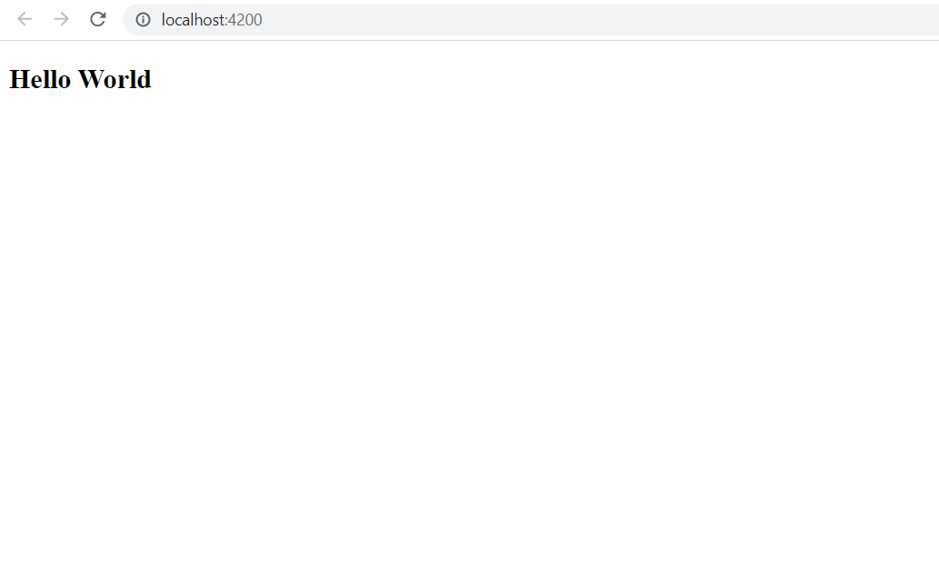

**Display favorite movie**

**app.component.ts**

import { Component } from '@angular/core';

@Component({

  selector: 'app-root',

 // templateUrl: './app.component.html',

  styleUrls: ['./app.component.css'],

  template: `

  <span>{{ title }} </span>

   <h1 [textContent]="favoritemovie"></h1>

    `,

})

export class AppComponent {

  title = 'Favorite Movie:';

  favoritemovie='Lord of the Rings';

}

**app.component.spects.ts**

import { DebugElement } from '@angular/core';

import { TestBed } from '@angular/core/testing';

import { RouterTestingModule } from '@angular/router/testing';

import { AppComponent } from './app.component';

describe('AppComponent', () => {

  beforeEach(async () => {

    await TestBed.configureTestingModule({

      imports: [

        RouterTestingModule

      ],

      declarations: [

        AppComponent

      ],

    }).compileComponents();

  });

  it('should create the app', () => {

    const fixture = TestBed.createComponent(AppComponent);

    const app = fixture.componentInstance;

    expect(app).toBeTruthy();

  });

  it(`should have as title 'Favorite Movie:'`, () => {

    const fixture = TestBed.createComponent(AppComponent);

    const app = fixture.componentInstance;

    expect(app.title).toEqual('Favorite Movie:');

  });

  it('should render movie name in a h1 tag', () => { //6

    const fixture = TestBed.createComponent(AppComponent);

    fixture.detectChanges();

    const compiled = fixture.debugElement.nativeElement;

    expect(compiled.querySelector('h1').textContent).toEqual('Lord of the Rings');

  });

});

**Output:**

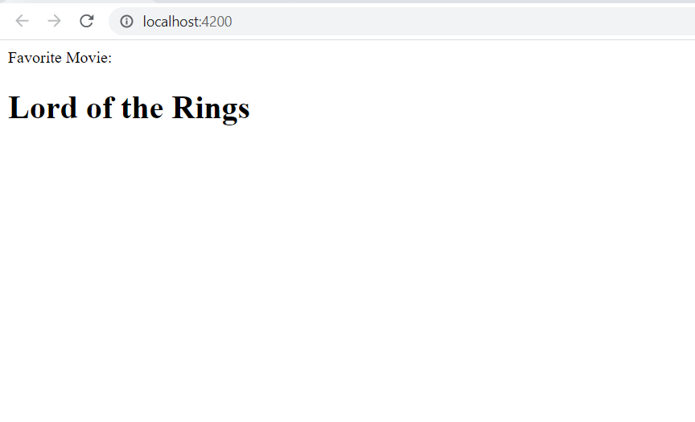

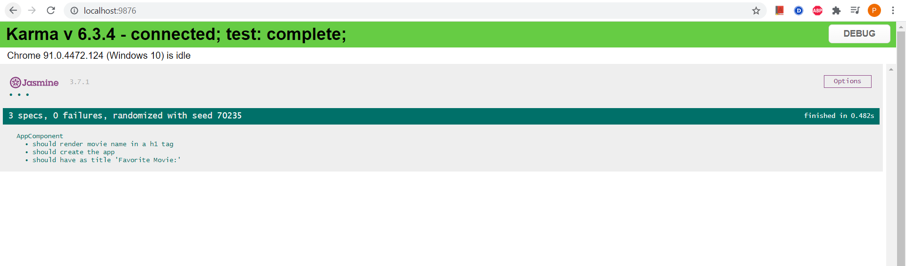

**Display Employee details**

**app.component.ts**

import { Component } from '@angular/core';

import { Employee } from './interface-component';

@Component({

  selector: 'app-root',

 templateUrl: './app.component.html',

  styleUrls: ['./app.component.css'],

})

export class AppComponent {

  title = 'Favorite Movie:';

  heading='Employee Details';

  ID=3;

    Name='John';

    Salary=10000;

}

**interface-component.ts**

export interface Employee {

    ID:number;

    Name:string;

    Salary:number;

}

**app.component.html**

    <h3>{{heading}}</h3>

    <p><strong>ID:</strong>{{ID}}</p>

    <p><strong>Name:</strong>{{Name}}</p>

    <p><strong>Salary:</strong>{{Salary}}</p>

**Output:**

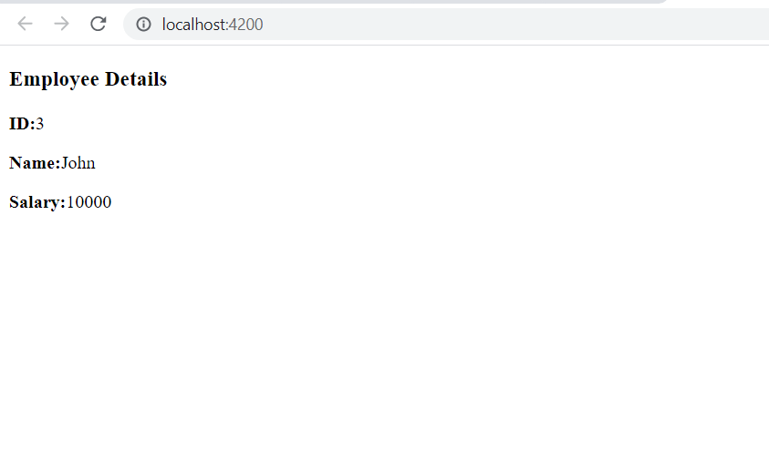

**Display employee permanent details using ngIf**

**app.component.ts**

import { Component } from '@angular/core';

import { Employee } from './interface-component';

@Component({

  selector: 'app-root',

 templateUrl: './app.component.html',

  styleUrls: ['./app.component.css'],

  // template: `

  // <span>{{ title }} </span>

  //  <h1 [textContent]="favoritemovie"></h1>

  //   `,

})

export class AppComponent {

  title = 'Favorite Movie:';

  heading='Employee Details';

  condition=true;

  ID=3;

    Name='John';

    Salary=10000;

}

**app.component.html**

    <!-- <span>{{ title }} app is running!</span> -->

    <div>

    <h3>{{heading}}</h3>

    <p><strong>ID:</strong>{{ID}}</p>

    <p><strong>Name:</strong>{{Name}}</p>

    <p><strong>Salary:</strong>{{Salary}}</p>

    <p *ngIf="condition">

      <strong>Permenant</strong>Yes

  </p>

</div>

**Output:**

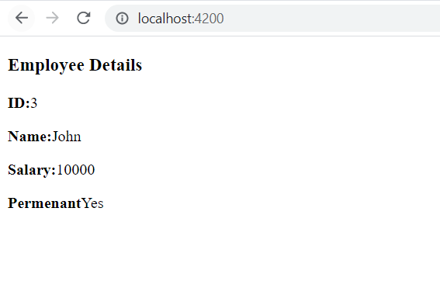

**Display employee department details**

**Interface-component.ts**

export interface Employee {

    ID:number;

    Name:string;

    Salary:number;

}

export interface Department{

    ID:number;

    Name:string;

    Salary:number;

    Permenant:boolean;

    Departmentid:number;

    Departmentname:string;

}

export class Employee implements Department{

    ID: number;

    Name: string;

    Salary: number;

    Permenant: boolean;

    Departmentid: number;

    Departmentname: string;

    constructor(id:number, name:string, salary:number, permanent:boolean,deptid:number,deptname:string){

    this.ID = id;

    this.Name = name;

    this.Salary = salary;

    this.Permenant = permanent;

    this.Departmentid=deptid;

    this.Departmentname=deptname;

    }

    }

**app.component.ts**

import { Component } from '@angular/core';

import { Employee } from './interface-component';

@Component({

  selector: 'app-root',

 templateUrl: './app.component.html',

  styleUrls: ['./app.component.css'],

})

export class AppComponent {

  title = 'Favorite Movie:';

  // heading='Employee Details';

  emp1 = new Employee(3, "John", 10000, true,1,"Payroll");

}

**app.component.html**

    <!-- <span>{{ title }} app is running!</span> -->

    <div>

    <p><strong>ID:</strong>{{ID}}</p>

    <p><strong>Name:</strong>{{Name}}</p>

    <p><strong>Salary:</strong>{{Salary}}</p>

    <p ><strong>Permenant:</strong>{{Permenant}}</p>

    <p ><strong>Department Id:</strong>{{Departmentid}}</p>

    <p ><strong>Department Name:</strong>{{Departmentname}}</p>

</div>

**Output:**

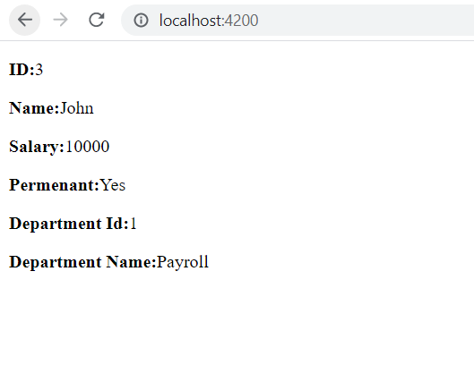

**Display employee skill details using ngFor**

**app.component.ts**

import { Component } from '@angular/core';

import { Employee} from './interface-component';

@Component({

  selector: 'app-root',

 templateUrl: './app.component.html',

  styleUrls: ['./app.component.css'],

})

export class AppComponent {

  title = 'Favorite Movie:';

  // heading='Employee Details';

  emp1 = new Employee(3, "John", 10000, true,1,"Payroll");

    public Skills:string[]=["Html","Css","JavaScripts"];

}

**app.component.html**

    <!-- <span>{{ title }} app is running!</span> -->

    <div>

    <p><strong>ID:</strong>{{emp1.ID}}</p>

    <p><strong>Name:</strong>{{emp1.Name}}</p>

    <p><strong>Salary:</strong>{{emp1.Salary}}</p>

    <p ><strong>Permenant:</strong>{{emp1.Permenant}}</p>

    <p ><strong>Department Id:</strong>{{emp1.Departmentid}}</p>

    <p ><strong>Department Name:</strong>{{emp1.Departmentname}}</p>

    <span><strong>Skill Id Skill Name</strong></span>

<ol type="1">

<li *ngFor="let item of Skills">{{item}}</li>

</ol>

</div>

**Output:**

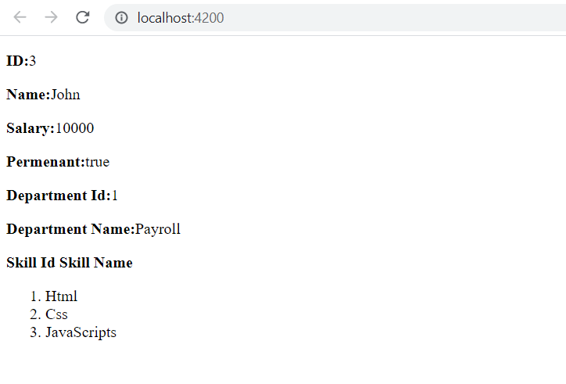

**Display employee details with date of birth**

**appcomponent.ts**

import { Component } from '@angular/core';

import { Employee} from './interface-component';

@Component({

  selector: 'app-root',

 templateUrl: './app.component.html',

  styleUrls: ['./app.component.css'],

})

export class AppComponent {

  title = 'Favorite Movie:';

  // heading='Employee Details';

  emp1 = new Employee(3, "John", 10000, true,1,"Payroll");

   Skills:string[]=["Html","Css","JavaScripts"];

    DateofBirth:Date=new Date('12/31/2000');

}

**app.component.html**

    <!-- <span>{{ title }} app is running!</span> -->

    <div>

    <p><strong>ID:</strong>{{emp1.ID}}</p>

    <p><strong>Name:</strong>{{emp1.Name}}</p>

    <p><strong>Salary:</strong>{{emp1.Salary}}</p>

    <p ><strong>Permenant:</strong>{{emp1.Permenant}}</p>

    <p ><strong>Department Id:</strong>{{emp1.Departmentid}}</p>

    <p ><strong>Department Name:</strong>{{emp1.Departmentname}}</p>

    <span><strong>Skill Id Skill Name</strong></span>

<ol type="1">

<li *ngFor="let item of Skills">{{item}}</li>

</ol>

<strong>Date Of Birth: </strong>{{DateofBirth}}

</div>

**Output:**

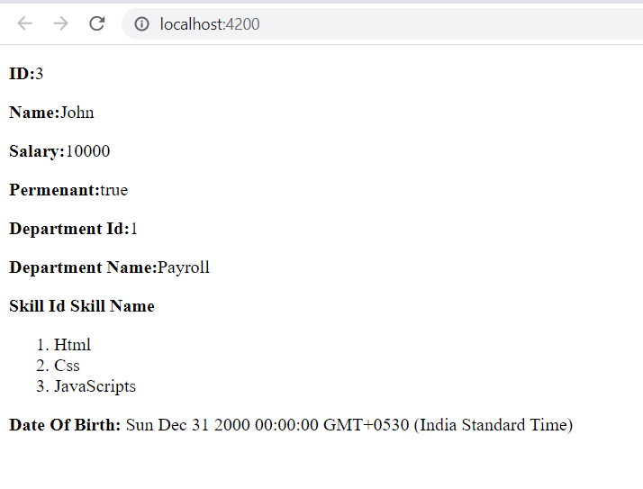

**Display employee date of birth and salary in custom format**

**app.component.ts**

import { Component } from '@angular/core';

import { Employee,Department} from './interface-component';

@Component({

  selector: 'app-root',

 templateUrl: './app.component.html',

  styleUrls: ['./app.component.css'],

})

export class AppComponent {

  title = 'Favorite Movie:';

  // heading='Employee Details';

public  emp1 = new Employee(3, "John", 10000, true,1,"Payroll");

Permanent:boolean=true;

   Skills:string[]=["Html","Css","JavaScripts"];

    DateofBirth:Date=new Date('12/31/2000');

}

**app.component.html**

    <!-- <span>{{ title }} app is running!</span> -->

    <div>

    <p><strong>ID:</strong>{{emp1.ID}}</p>

    <p><strong>Name:</strong>{{emp1.Name}}</p>

    <p><strong>Salary:</strong>{{emp1.Salary}}</p>

    <p ><strong>Permenant:</strong>{{emp1.Permenant}}</p>

    <p ><strong>Department Id:</strong>{{emp1.Departmentid}}</p>

    <p ><strong>Department Name:</strong>{{emp1.Departmentname}}</p>

    <span><strong>Skill Id Skill Name</strong></span>

<ol type="1">

<li *ngFor="let item of Skills">{{item}}</li>

</ol>

<strong>Date Of Birth: </strong>{{DateofBirth}}

</div>

<div>

<h1>Using Pipes</h1>

<strong>Id: </strong>{{emp1.ID}}<br><br>

<strong>Name: </strong>{{emp1.Name}}<br><br>

<strong>Salary: </strong>{{emp1.Salary | currency:"INR"}}

<br><br>

<span *ngIf="Permanent"><strong>Permanent:</strong>Yes</span>

<br><br>

<strong>Department Id: </strong>{{emp1.Departmentid}}

<br><br>

<strong>Department Name: </strong>{{emp1.Departmentname}}

<br><br>

<strong>Skills</strong>

<br><br>

<span><strong>Skill Id Skill Name</strong></span>

<ol type="1">

<li *ngFor="let item of Skills">{{item}}</li>

</ol>

<strong>Date Of Birth:</strong>{{DateofBirth | date}}

</div>

**Output:**

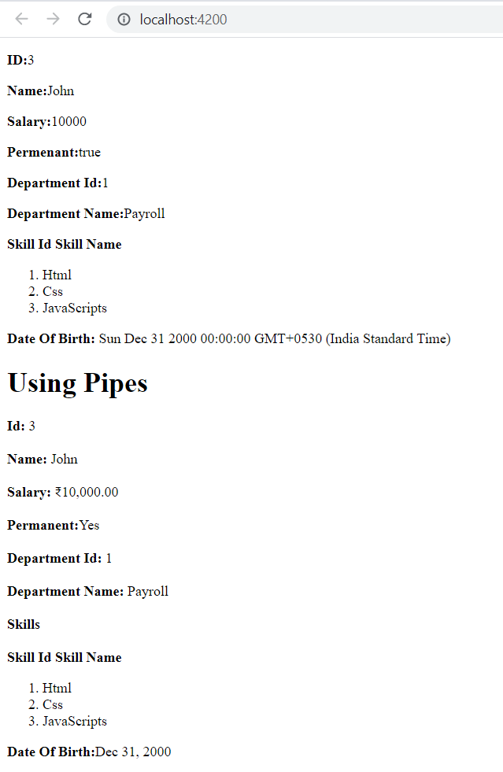

**SESSION2**

**Create View Employee Component**

**Display value based on button click**

**Event Handling and Two Way Binding - increment value in textbox based on button click**

**app.module.ts**

import { NgModule } from '@angular/core';

import { BrowserModule } from '@angular/platform-browser';

import { AppRoutingModule } from './app-routing.module';

import { AppComponent } from './app.component';

import { EditempComponent } from './editemp/editemp.component';

import { QuantityIncrementComponent } from './quantity-increment/quantity-increment.component';

import { ViewempsComponent } from './viewemps/viewemps.component';

import {Routes,RouterModule} from '@angular/router'

const appRoutes:Routes=[{path:"" , component:ViewempsComponent},

  {path:"EditEmployees" ,

  component:EditempComponent},{path:"QuantityIncrement",component:QuantityIncrementComponent}]

@NgModule({

  declarations: [

    AppComponent,

    ViewempsComponent,

    EditempComponent,

    QuantityIncrementComponent,

  ],

  imports: [

    BrowserModule,

    AppRoutingModule,

    RouterModule.forRoot(appRoutes)

  ],

  providers: [],

  bootstrap: [AppComponent]

})

export class AppModule { }

**app.component.ts**

import { Component } from '@angular/core';

import { Employee,Department} from './interface-component';

@Component({

  selector: 'app-root',

 templateUrl: './app.component.html',

  styleUrls: ['./app.component.css'],

})

export class AppComponent {

}

**App component.html**

<style>

    body { font-family: Segoe UI, Arial

  }  a { text-decoration: none }

  </style>

  <h3>Angular Learning <br><a [routerLink]="['/']">View Employees</a> ||<a [routerLink]="['/EditEmployees']">Edit Employees</a>||

    <a [routerLink]="['QuantityIncrement']">Quantity Increment</a></h3>

  <div>

  <router-outlet></router-outlet>

**Quantity-increment.component.html**

<p>Simple Button click Event!!</p>

<button (click)="firstbutton()">Click Me</button>

<br>

<br>

{{result}}

<br>

<input type="text" value={{num}}><button (click)="Add()">add</button>

<br>

<br>

<input type="submit" value="sub" (click)="sub1()" [disabled]="flag"><input type="text" value={{addandsub}}><input type="submit" value="add" (click)="add1()">

**Quantity-increment.component.ts**

import { Component, OnInit } from '@angular/core';

@Component({

  selector: 'app-quantity-increment',

  templateUrl: './quantity-increment.component.html'

})

export class QuantityIncrementComponent {

  public result:string="";

  public firstbutton():void{

    this.result="click me button clicked";

  }

  public num:number=0;

  public Add():void{

    this.num++;

  }

  public addandsub:number=0;

  public flag:boolean=true;

  public add1():void{

    this.addandsub++;

    if(this.addandsub>0){

      this.flag=false;

    }

    else{

      this.flag=true;

    }

  }

  public sub1():void{

    this.addandsub--;

    if(this.addandsub>0){

      this.flag=false;

    }

    else{

      this.flag=true;

    }

  }

}

**Edit.component.ts**

<p>editemp works!</p>

**Edit.component.ts**

import { Component, OnInit } from '@angular/core';

@Component({

  selector: 'app-editemp',

  templateUrl: './editemp.component.html'

})

export class EditempComponent implements OnInit {

  constructor() { }

  ngOnInit(): void {

  }

}

**Viewemps.component.html**

<strong>Id:</strong>{{Id}}<br><br>

<strong>Name:</strong>{{Name}}<br><br>

<strong>Salary:</strong>{{Salary | currency:"INR"}}

<br><br>

<span *ngIf="Permanent"><strong>Permanent:</strong>Yes</span>

<br><br>

<strong>Department Id:</strong>{{Department_Id}}

<br><br>

<strong>Department Name:</strong>{{Department_Name}}

<br><br>

<strong>Skills</strong>

<br><br>

<span><strong>Skill Id Skill Name</strong></span>

<ol type="1">

    <li *ngFor="let item of Skills">{{item}}</li>

</ol>

<br>

<br>

<strong>Date Of Birth:</strong>{{DateofBirth | date}}

**Viewemps.component.ts**

import { Component, OnInit } from '@angular/core';

@Component({

  selector: 'app-viewemps',

  templateUrl: './viewemps.component.html'

})

export class ViewempsComponent {

  public Id:number=1;

  public Name:string="John";

  public Salary:number=10000;

  public Permanent:boolean=true;

  public Department_Id:number=1;

  public Department_Name:string="payroll";

  public Skills:string[]=["Html","Css","JavaScripts"];

  public DateofBirth:Date=new Date('12/31/2000');

}

**Output:**

